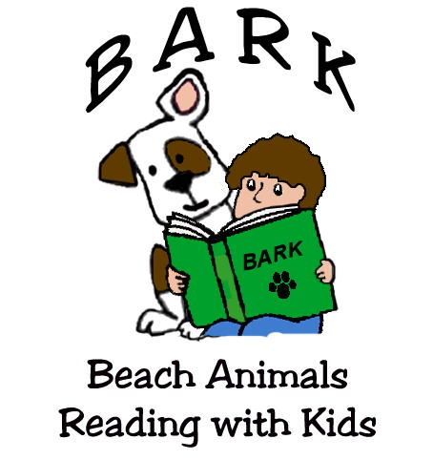

__________________ _____________
(Facility) (Date)

I give permission for my child to read with a BARK dog and to be photographed. I understand my child’s photo or likeness may be used for publicity without compensation. To the extent permitted by law, I agree to indemnify BARK while participating in this program.

 | Child’s Name | Parent’s Name | Parent’s Signature | Dog
1
2
3
4
5
6
7
8
9
10
11
12
13
14
15
16
17
18
19
20
21
22
23
24
25
Revised Feb 2013

