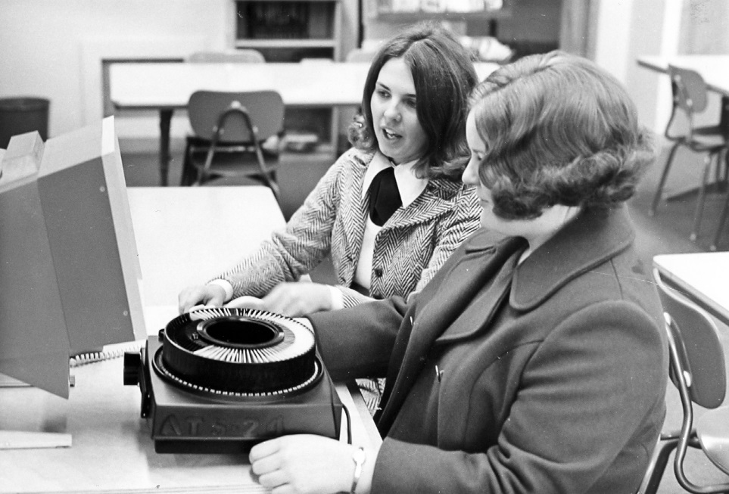

Name (please print clearly) :_____________________________ Madison College Email:_______________________________
Campus:______________________________ Please turn in to library service desk upon completion to be entered in contest

