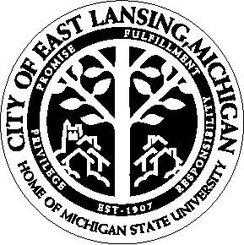 | Communications Department  410 Abbot Road  East Lansing, MI 48823  (517) 337-1731 phone  (517) 337-1607 fax  www.cityofeastlansing.com | Media Contact:  Kristin Shelley  Director  East Lansing Public Library  (517) 351-2420

News Release
Community Ambassadors Sought for East Lansing Welcomes the World

13-090
July 31, 2026

EAST LANSING, Mich. — Community ambassadors are needed for the 4th Annual East Lansing Welcomes the World event, taking place Sunday, Sept. 8 from 2:30-4:30 p.m. at the East Lansing Public Library (ELPL), 950 Abbot Road.

This special community event will serve to welcome international students and families to the East Lansing community. Community ambassadors are needed to help welcome and create friendly dialogue with the international participants.

The event will feature mingling, catered food, live music, children’s activities, community resource tables and more. There will also be a program featuring brief remarks by Michigan State University and City of East Lansing officials.

Community ambassadors will help set up the event and meet and greet students and families as they arrive. Community members interested in signing up to be a community ambassador can contact ELPL’s Phyllis Thode at pthode@cityofeastlansing.com or Jen Amormino at jamormi@cityofeastlansing.com.

“This is a great opportunity for local community members to volunteer their time for a great cause,” said ELPL Director Kristin Shelley. “The international student population in East Lansing continues to grow and is an important part of our community. The East Lansing Welcomes the World event provides an opportunity to reach out to these valued community members and make them feel at home.”

East Lansing Welcomes the World is hosted by MSU, the City of East Lansing and – new this year – Lansing Community College. ELPL is located at 950 Abbot Road. Community members with questions about the event can contact ELPL at (517) 351-2420.

###

