Club de Lecture

Teen Reading Buddy Application

Your Name:
Phone: Emergency Phone:
Email: Birthdate:
School: _____________________________________________________________________________

IMPORTANT, PLEASE READ:
- Please arrive on time, and call us at 604-527-4677 if you can’t make it.
- Meetings with buddies are every Wednesday at 3:30 from January 21st to March 4th.

_____________________________________ ________________________
Signature of teen Date Signed

Other Information:
Have you ever tutored or volunteered with young children before? If Yes, briefly describe your experience.
__________________________________________________________________________________
__________________________________________________________________________________
What types of books do you like to read?
__________________________________________________________________________________
__________________________________________________________________________________
__________________________________________________________________________________

Parental Permission:
I hereby give permission for my son/daughter ________________________________ to volunteer as a Reading Buddy (Club de Lecture) at the New Westminster Public Library. All participants will be under the supervision of the coordinating librarian at all times.
My son/daughter has the following allergies: _________________________________________

_____________________________________ __________________________
Signature of Parent or Guardian Date Signed
_____________________________________
Please print parent name here
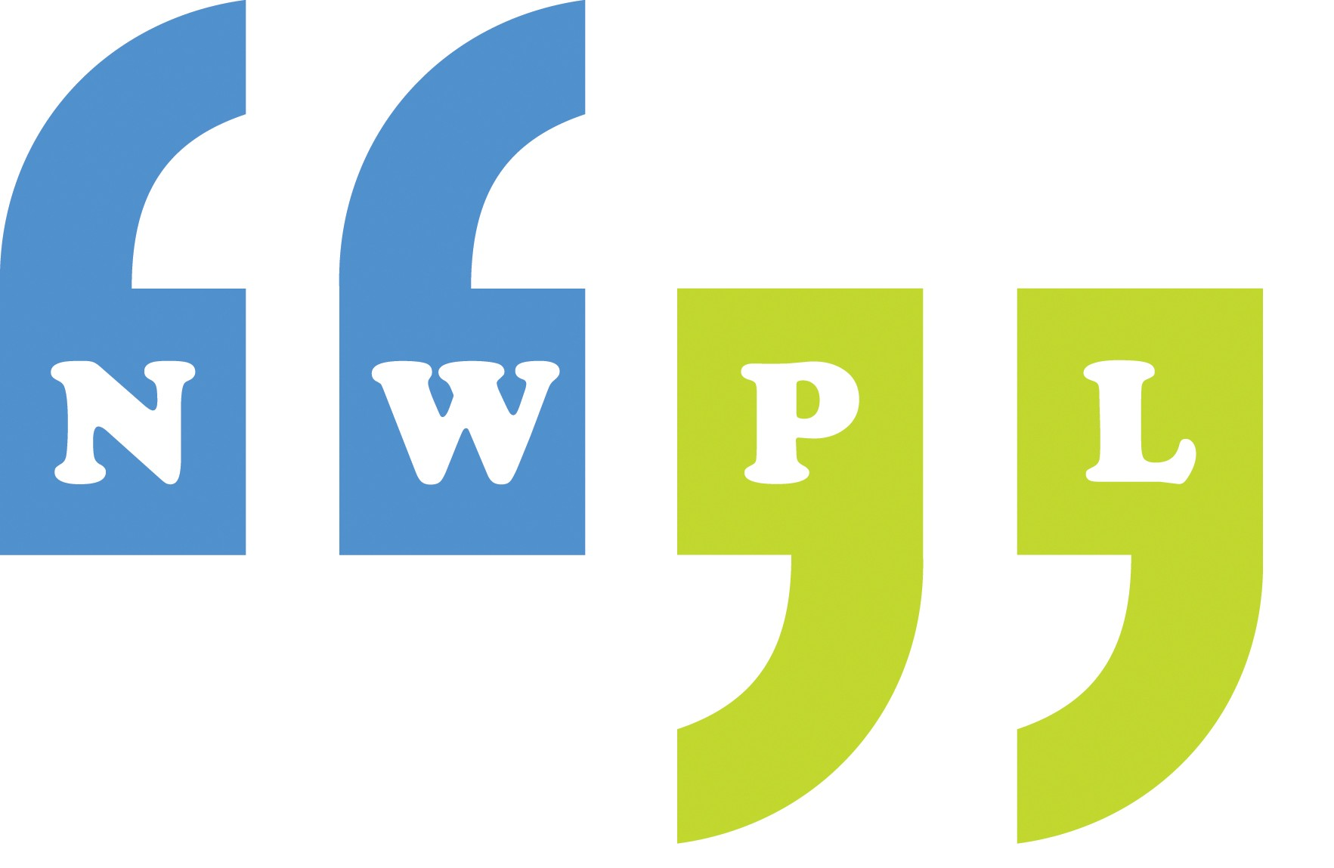
716 – 6th Avenue, New Westminster, B.C. V3M 2B3, 604-527-4677

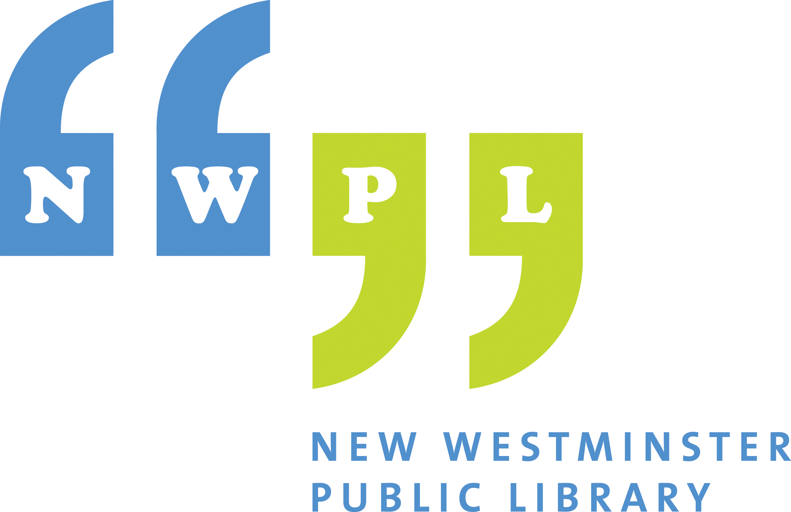 New Westminster Public Library

Photograph Release Form

I grant to the New Westminster Public Library (the “Library”) the right to reproduce, exhibit, print and distribute photographed images of me taken at the Library or during Library programmes. I understand that these photos may be used on the Library’s website (www.nwpl.ca), in published reports, or for other promotional reasons and in other formats and media. I understand that the Library may use these photos at anytime in the future, or may discontinue use of these photos without notifying me.

No personal information will be disclosed with the photo, including the subject’s name, address, or any other contact information. If, at any time, you would like your photo removed from the Library’s web site, please contact the Library’s Webmaster at webmaster@nwpl.ca

For Photographs of Adults 18 Years of Age and Older

Name (please print)

Address:

Phone Number:

Signature:

Date:

For Photographs of Children Under the age of 18

Child’s Name:

Parent’s Name:

Address:

Phone Number:

Signature:

Date:

New Westminster Public Library

