The IG Flyer Posts (posted once weekly for the duration of the series on www.instagram.com/durantlibrary; listed here as 4 print screen images with links):
Week 1, February 5, 2021 for Jacob Lawrence: https://www.instagram.com/p/CKxRB-EpfW6/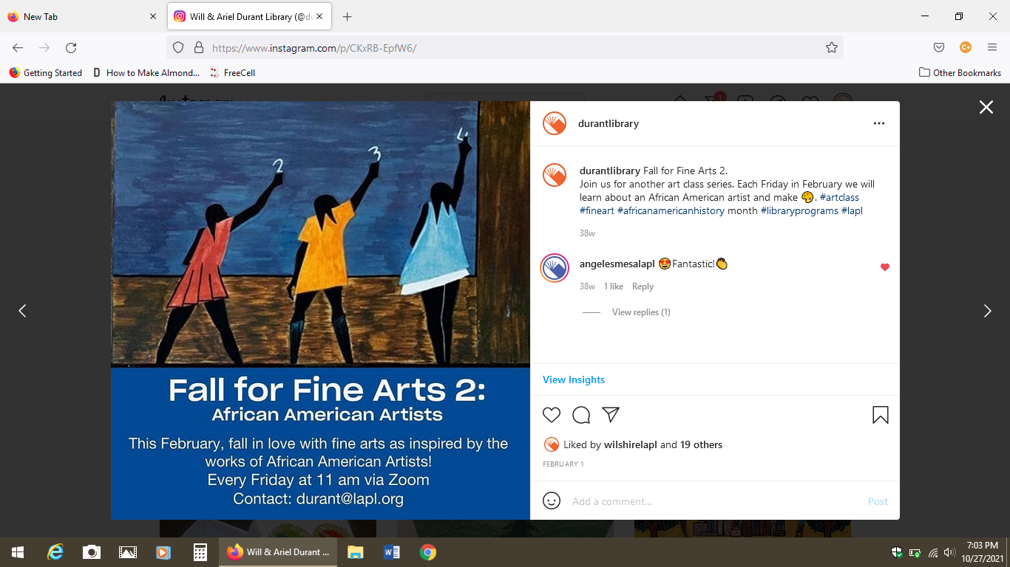

Week 2, February 12, 2021 for Clementine Hunter: https://www.instagram.com/p/CLFT_D6pEaA/ 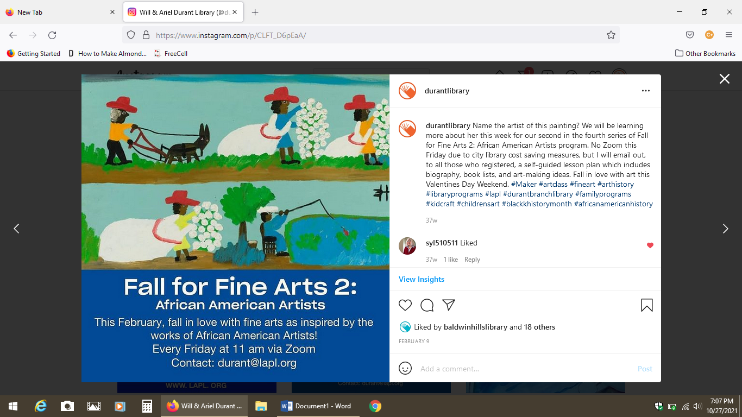

Week 3, February 19, 2021 for Alma W. Thomas: https://www.instagram.com/p/CLXXWE3pALi/
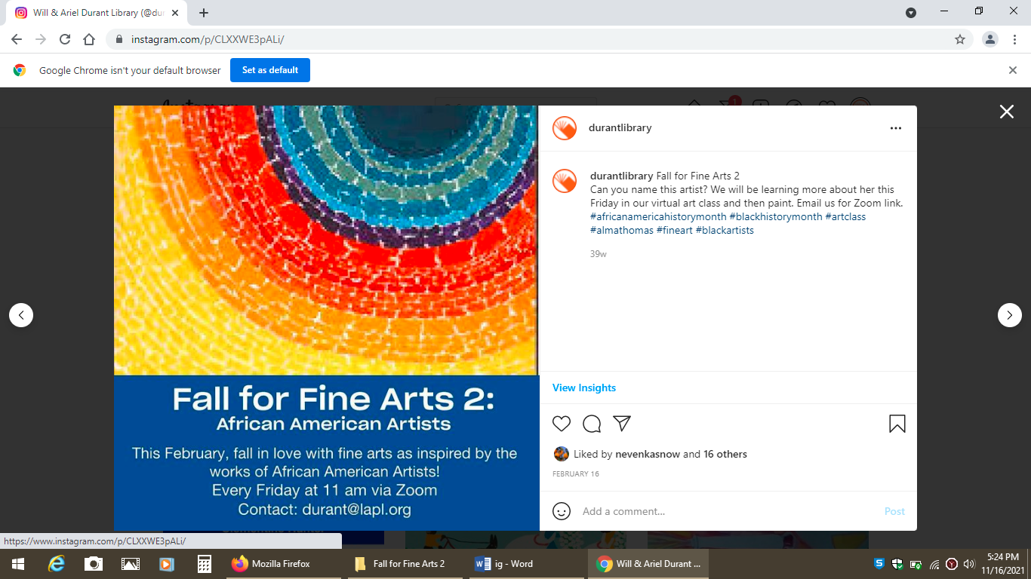

Week 4, February 26, 2021 for Tom Feelings: https://www.instagram.com/p/CLm30NUJCuA/ 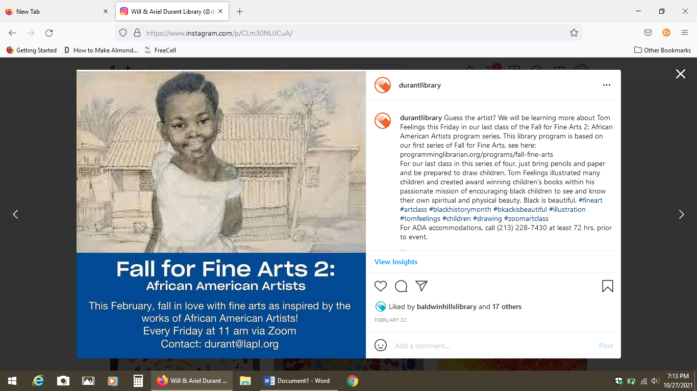

If you wish to duplicate something similar, here is one of the .jpg example templates (just swap image and text):

