Creative Engagement Toolkit -
Youth

Created by Katy Scott for
Kansas City Public Library Outreach
2018

What is Creative Engagement?
The goal of Creative Engagement is to provide elementary and middle school aged participants with open ended creative opportunities that tie into Library offerings. While many arts and crafts classes focus on creating a specific final product, Creative Engagement sessions focus instead on encouraging participants to think outside the box, challenge their perceptions of their abilities, and flex their imaginations. Participants will all do the same activity, but everyone’s project will be unique.
Projects
The projects included in this toolkit are adaptable for many age groups and skill levels. Each project also ties in with a Library book or digital resource, allowing for cross promotion of Library services. This toolkit is just the beginning of possibilities for Creative Engagement - I encourage you to add to it for your own use!
The following websites are great inspiration:
Deep Space Sparkle : Famous Artist Lesson Plans
Deep Space Sparkle : Color Theory Lesson Plans
Incredible Art : Elementary Lessons by Artist
Incredible Art : Middle School Lessons by Artist
General Tips
- Have all participants name and date their projects
- If you are hosting multiple Creative Engagement sessions, consider keeping a folder of each participants’ projects throughout the program. At the end of the program, each participant will have their own portfolio of artwork
- Act as a facilitator, not an instructor; give participants the freedom to take the project where they want, and provide encouragement and suggestions as needed
- Consider hosting a “gallery opening” style event at the end of the sessions, where participants can proudly display their artwork. Would you like the Library’s Outreach department to participate in some way? Contact us at communityresources@kcibrary.org

Project: “I Am” Collage
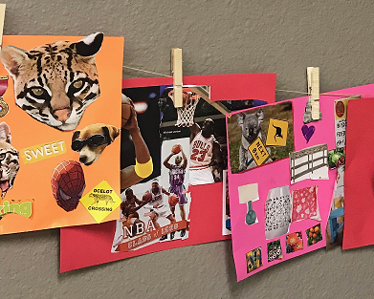

Overview & Purpose
For this project, participants will create a collage that represents their interests, dreams, and best qualities using images and words cut from magazines or other sources. This project encourages self reflection and creativity, and strengthens motor and sharing skills.

Materials Needed
- Magazines, picture books, coloring books, etc.
(Remember, these will be cut up!)
- Scissors
- Glue Sticks
- Cardstock or other stiff paper
- Optional: Example project

Project Steps
- Pass out cardstock, glue, and scissors to each table
- Explain project concept to participants
Ex: “For today’s project, we’re going to be making a collage that represents all the awesome things about ourselves. You’ll go through the magazines and find pictures and words that describe you. Maybe you’ll cut out a picture of a basketball because you love sports, or words like “bright”, “silly”, or “strong”. Glue your pictures and words onto the paper however you want to create your work of art!”
- Distribute magazines as you see fit - encourage participants share magazines so everyone gets a variety
- Encourage participants to look at magazines creatively and assist younger participants with use of supplies if needed

Library Tie In Ideas
- K-2nd: Read “What’s Your Favorite Animal” by Eric Carle and talk about the collage art style
- 3rd - 5th: Read “Romare Bearden: Collage of Memories” by Jan Greenberg to learn about Greenberg and introduce the concept of collage
- Middle School: Share books like “What It Is” by Lynda Barry and “Collage Discovery Workshop” by Claudine Hellmuth with participants while discussing the concept of collage, materials used, thinking outside the box, etc.

Tips & Things to Consider
- Encourage participants to cut out and glue on their own - lines don’t need to be straight and things don’t need to be perfect!
- Engage with the participants by asking them what certain images represent, what words describe them, etc.
- Encourage participants to look in all of the magazines, even ones they don’t think they’ll like - you never know what you can find!

Project: Cubism 101

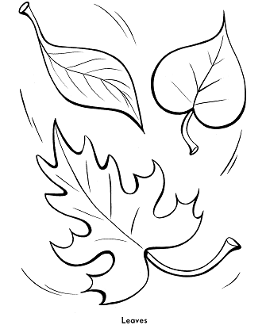
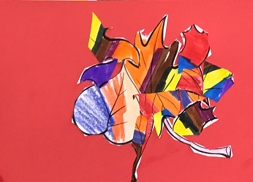
→

Overview & Purpose
For this project, participants will cut up a picture they’ve colored and rearrange the pieces in a unique way to create a completely new piece of art. This project encourages participants to think outside the box and introduces them to the cubism art style.

Materials Needed
- Blank coloring sheets
- Crayons, markers, or colored pencils
- Scissors
- Glue Sticks
- Cardstock or other stiff paper
- Optional: example project

Project Steps
- Pass out cardstock, glue, and scissors to each table
- Explain project to participants
Ex: “One way to create art is to take something that already exists and change it in some way. Today we’re all going to color the same coloring sheet, but we’re going to end up with a completely unique product. First you’ll color the coloring sheet however you want, then you’re going to cut it up and rearrange it on your paper. You can make anything you want - get creative and have fun!”
- Distribute coloring sheets and coloring materials
- Assist younger participants as needed

Library Tie In Ideas
- K-3rd: start the session with this quote from Picasso, “Every child is an artist. The problem is how to remain an artist once we grow up”. Explain that Picasso was an artist that used cubism. Use a kid-friendly art book such as “Cubism” by Linda Bolton to show examples of cubism and talk about using lots of colors and shapes.
- 4th - middle school: ask the students to name artists that they can think of. Discuss abstract art and cubism. Show a video from digital resource Khan Academy such as “The Case For Abstractism” and discuss how to create something abstract out of something straight forward

Tips & Things to Consider
- Some participants may be uncomfortable cutting up their coloring sheet; encourage them to try something new, but don’t be too pushy. The point is to create something at the end of the day - even if it’s not what the original concept was!
- To make this project more challenging for older participants, consider stretching this project over two sessions and having each participant draw and color their own picture, then rearrange it as they see fit for the cubism element.
- If you’re able, photograph what each coloring sheet looked like before, and what the final product was, to help show the creative changes made by each artist

Project: Watercolor Resist Painting

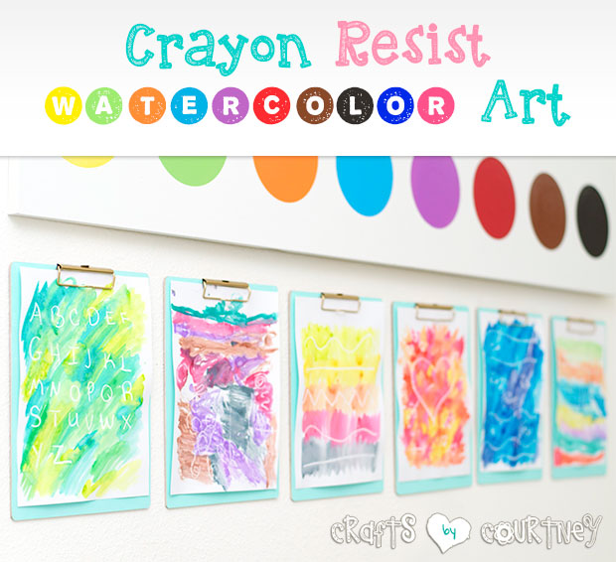

Overview & Purpose
For this project, participants will learn about negative space by coloring with crayons, then painting with watercolor. Using this resistance technique, the paint will not stick to the areas that have been colored with crayon, creating negative space. This project can be adapted to focus on certain colors or shapes, and assists with the development of fine motor skills.

Materials Needed
- Cardstock
- White crayons
- Watercolor Paints
- Paint brushes
- Water and cups
- Optional: example project

Project Steps
- Hand out cardstock and crayons
- Explain project to participants, including any theme you have chosen for the session(Animals, Space, Shapes, Color, etc.) -
Ex - “Today’s project is going to teach us about negative space in art. First, we’re going to draw whatever we want on a piece of paper with a white crayon. Press really hard with the crayon! Then, we’re going to paint on top of the picture. The places where we drew with crayon, the paint won’t stick, so it’ll stay white, and all the colors will show up around it. You might draw a picture of your friends, a park, outer space - and you’ll end up with a really cool painting!”
- Hand out painting supplies part way through the session
- Provide feedback and encouragement throughout project

Library Tie In Ideas
- K-2nd: Instead of a white crayon, use a purple one and tie this project in to the reading of “Harold and the Purple Crayon” by Crockett Johnson
- 3rd-middle school: Provide themed Library books for project inspiration; for example, if the session is space themed, have books with photographs and illustrations of space available to inspire participants
Tips & Things to Consider
- Make sure your watercolors are washable
- This project can be messy with younger participants, so consider using smocks if available, and have paper towels on hand
- Encourage the participants to press very hard with the crayon for the best results
- Any color of crayon and paint can be used for this project
- To reduce the length and complexity of this project, have participants trace over a coloring sheet with crayon instead of creating their own design

Project: Continuous Line Monsters
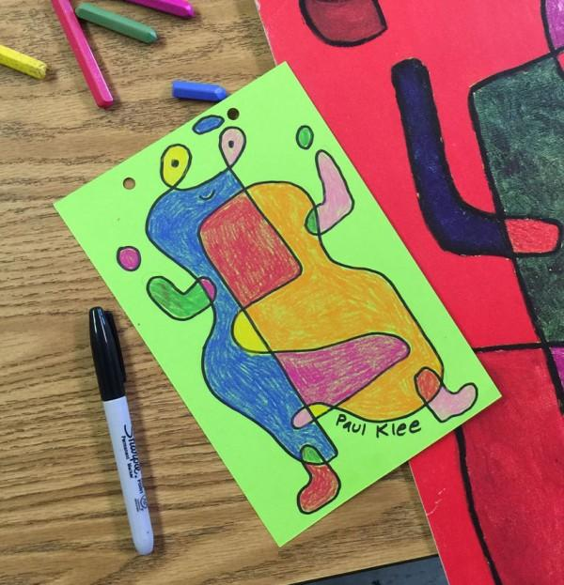
Photo courtesy of Art Projects for Kids

Overview & Purpose
This project allows participants to create their own monster and challenges them to do so with one continuous line. This project teaches art history by exploring surreal and abstract art and artists, such as Paul Klee, and encourages storytelling through the creation of fictional monsters.

Materials Needed
- Cardstock
- Crayons, colored pencils, or markers

Project Steps
- Hand out cardstock and drawing utensils
- Explain project -
Ex. “One way to get creativity flowing is to challenge yourself. Today, we’re going challenge ourselves to create a monster - scary or sweet - without ever lifting the pencil off the page. You can make your monster however you want, just as long as you never lift up your pencil! After you’ve drawn your monster, color it in, give it a name, and write something about the monster, like their favorite food or color, to help us get to know them better.”
- Facilitate the project by encouraging participants to keep going even if they accidentally lift up their pencil, and asking participants about the personalities of their monsters

Library Tie In Ideas
- K-2nd: Read the book “Lines That Wiggle” by Candace Whitman and talk about how the same line follows through the whole book and becomes many different things. Ask the participants to identify the different things that the line can be, then use some of those ideas when they create their own line monsters.
- 3rd - Middle School: Show a video on character creation from digital resource Khan Academy, such as “Internal vs External Features” from the Pixar in a Box series. Use this video to spur inspiration for the monster’s character traits, both on the inside and the outside.
Tips & Things to Consider
- For older participants, project can focus on creative writing as well as art. Instead of justs writing something about the character, adjust the project to last multiple sessions. Have one session focus on visual character creation with the one line drawing, and the next session focus on character development and writing a biography or story for the character.
- Encourage participants to try new things and turn “mistakes” into unique features of the character instead.

